Glamour Glow Supply chain Sales & Profit Performance

**Overall Performance:**

* **Strong Revenue & Profit:** The company has generated significant revenue ($377.60K) and profit ($519.48K), indicating a healthy financial standing.
* **High Product Volume:** 46,099 products sold across 4,922 orders suggest a considerable market presence and operational scale.

**Product Sales & Profitability:**

* **Skincare Dominance in Sales Volume:** Skincare products lead in sales volume (20,731 units) compared to haircare (13,011 units) and cosmetics (11,757 units).
* **Cosmetics are Highly Profitable per Unit:** While skincare sells the most units, the "Profit by Customer Demographics" section shows cosmetics contributing significant profit, especially from female customers. This suggests cosmetics might have a higher profit margin per unit compared to skincare or haircare.
* **Top 10 Products by Type:** SKUU90 (skincare) is the top-selling product by type. There's a good mix of skincare, haircare, and cosmetics within the top sellers, indicating diversification.
* **Top 5 Products by Price & Demand:** The visualization shows higher prices correlating with higher demand for certain products (e.g., SKU23 and SKU09, both haircare, and SKU50, cosmetics). This is interesting and suggests that customers are willing to pay more for perceived value or quality in these categories.
* **Top 10 Profitable Products by Availability:** SKU34 (skincare) and SKU43 (skincare) appear to be the most profitable products by availability, indicating strong demand and perhaps good inventory management for these items.

**Customer Demographics & Profitability:**

* **Female Customers are the Most Profitable:** Female customers contribute the highest profit across all product categories, especially for cosmetics ($63K) and skincare ($72K).
* **Male and Non-binary Customers also Contribute:** While less than females, these segments still contribute substantial profit, indicating a diverse customer base.
* **"Unknown" Demographics:** A significant portion of profit comes from "Unknown" customer demographics. This highlights a data collection gap.

**Supplier Performance (Profit Details Customer Vs Supplier):**

* **Supplier 1 Appears Strong:** Supplier 1 seems to be a major contributor across various product types and customer segments.
* **Varying Supplier Performance:** There's a clear difference in profit contribution from different suppliers across categories and customer types. For example, Supplier 3 seems strong for female haircare, while Supplier 2 is strong for male cosmetics.

**Business Recommendations**

1. **Capitalize on Female Customer Base:**
   * **Recommendation:** Continue to focus marketing and product development efforts on female customers, especially for skincare and cosmetics, given their high profitability.
   * **Action:** Launch targeted campaigns, loyalty programs, and new product lines specifically designed for female preferences. Consider collaborations with influencers popular among female demographics.
2. **Optimize Cosmetics Profitability:**
   * **Recommendation:** Invest in understanding why cosmetics are so profitable, even with lower sales volume compared to skincare.
   * **Action:** Analyze the cost of goods sold (COGS), pricing strategies, and marketing efforts for cosmetics. Explore opportunities to increase sales volume for these high-margin products without compromising profitability, perhaps through bundling or strategic promotions.
3. **Address "Unknown" Customer Demographics:**
   * **Recommendation:** Implement strategies to gather more demographic data from customers.
   * **Action:** Review and optimize your customer data collection processes at various touchpoints (e.g., website sign-ups, purchase checkout, loyalty programs). This data is crucial for more granular segmentation and targeted marketing.
4. **Leverage Top-Performing Products:**
   * **Recommendation:** Analyze the success factors of the "Top 10 Products by Type" and "Top 10 Profitable Products by Availability."
   * **Action:** Replicate the success of these products where possible. Understand their unique selling propositions (USPs), marketing strategies, and supply chain efficiencies. Consider cross-selling and upselling these popular items.
5. **Strategic Pricing Based on Demand:**
   * **Recommendation:** Continue to monitor and optimize pricing based on demand, especially for products where higher prices correlate with higher demand (e.g., SKU023, SKU09, SKUU50).
   * **Action:** Conduct price elasticity analysis for various products. Don't be afraid to maintain premium pricing for products that customers perceive as high-value.
6. **Optimize Supplier Relationships:**
   * **Recommendation:** Conduct a detailed analysis of supplier performance based on profit contribution, cost, quality, and reliability.
   * **Action:** Consider negotiating better terms with less profitable suppliers or exploring alternative suppliers if performance is consistently low. Strengthen relationships with high-performing suppliers like Supplier 1. Potentially diversify suppliers for critical product categories to mitigate risks.
7. **Explore Growth in Male and Non-binary Segments:**
   * **Recommendation:** While female customers are the primary focus, there's clear profit potential in male and non-binary segments.
   * **Action:** Research specific needs and preferences of these customer groups. Develop targeted marketing campaigns and products (e.g., gender-neutral packaging, products addressing specific male skincare/haircare concerns) to grow these segments.
8. **Deep Dive into Category-Specific Performance:**
   * **Recommendation:** Further analyze the performance within each category (skincare, haircare, cosmetics) across all metrics.
   * **Action:** Identify underperforming products within each category and either improve their performance or consider phasing them out. Identify opportunities for new product development or expansion within each category.

By implementing these recommendations, Glamour Glow Cosmetics can further enhance its supply chain efficiency, optimize profitability, and streng then its market position.

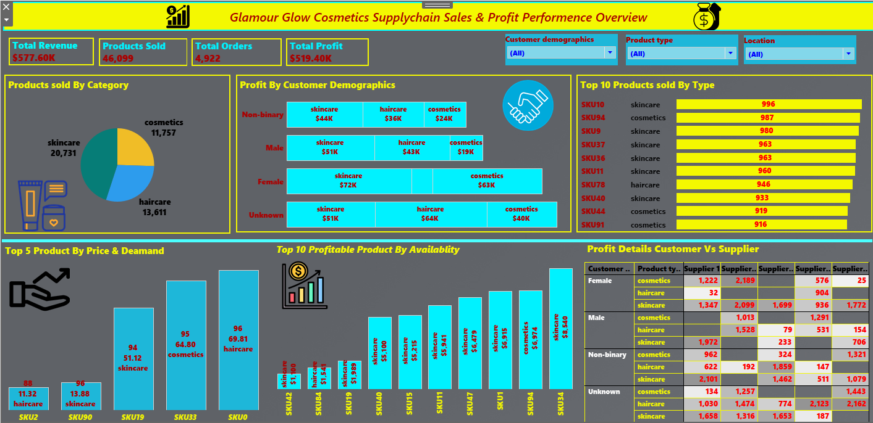

Glamour Glow Supply chain Shipping & Orders Performance

Overall Shipping Performance:

* Total Shipping Costs: $554.81, which is a moderate cost for the operations.
* Average Shipping Lead Time: 17.08 days, which seems quite long for cosmetic products. This could be a significant point of improvement.
* Average Shipping Time: 575 (units not specified, but if it's hours, it's also very long; if it's minutes, it's very short; clarification needed). Assuming it refers to total time, this aligns with the long lead time.

Carrier Performance:

* Shipping Lead Time & Shipping Costs:
  + Carrier B: Has the longest average lead time (18.3 days) and the highest shipping costs ($236.90). This indicates it's the least efficient or most expensive carrier.
  + Carrier A: Has the shortest average lead time (17.1 days) and lower shipping costs ($159.54) compared to Carrier B.
  + Carrier C: Also has a lead time of 17.1 days, but its shipping costs ($162.38) are slightly higher than Carrier A.
* Performance of Shipping Carrier (Avg. Lead Time by Product Type):
  + Carrier B: Consistently shows higher average lead times across all product types (skincare, haircare, cosmetics).
  + Carrier A & C: Generally perform better than Carrier B in terms of lead time across product types.
* Profit by Shipping Carrier:
  + Carrier C: Generates the highest profit ($9,708), suggesting it handles a large volume of profitable orders, or is particularly cost-effective for high-value goods.
  + Carrier B: Generates the lowest profit ($4,543), further cementing its position as the least efficient/profitable carrier.
  + Carrier A: Falls in the middle ($5,230).

Inventory Status:

* Stock Levels by Product Type:
  + Skincare: 1,600 units
  + Haircare: 1,684 units (highest stock)
  + Cosmetics: 1,525 units
  + The inventory levels appear relatively balanced across product types, but specific SKUs or fast/slow-moving items aren't detailed.
* Inventory Status by Warehouse Location:
  + Negative Inventory: Several locations show negative inventory (e.g., Kolkata -170 cosmetics, Delhi -120 skincare, Bangalore -112 cosmetics, Chennai -169 cosmetics, Chennai -100 haircare). This is a critical issue, often indicating data entry errors, unrecorded shipments, or products being sold before they are physically received.
  + Positive Inventory: Mumbai (168 haircare, 99 skincare) and Delhi (55 skincare) show positive inventory.

Order Details (Customer, Product, Supplier Performance):

* Female Customers: Have a high volume of orders across all suppliers, particularly for cosmetics and skincare. Supplier 1 and Supplier 3 appear to be dominant.
* Male Customers: Show a good spread, with Supplier 1 and Supplier 3 again being significant.
* Non-binary Customers: A considerable number of orders, with Supplier 1, Supplier 2, and Supplier 3 being prominent.
* Unknown Customers: A large number of orders, indicating a data gap similar to the previous dashboard. Supplier 1 and Supplier 4 have notable contributions here.
* Supplier 1 & 3 are Key: These two suppliers consistently handle a high volume of orders across various customer types and product categories.
* Supplier 4 is Significant for "Unknown": Supplier 4 seems to cater significantly to "Unknown" customer orders.

Business Recommendations

1. Prioritize Shipping Lead Time Reduction:
   * Recommendation: The average shipping lead time of 17.08 days is a major concern. It's too long for cosmetics, which often have higher customer expectations for quick delivery. This can negatively impact customer satisfaction and repeat business.
   * Action:
     + Phase out or renegotiate with Carrier B: Given its high costs and long lead times, evaluate the possibility of reducing reliance on Carrier B or securing better terms/service level agreements.
     + Leverage Carrier A & C: Analyze what makes Carrier A and C more efficient. Can more volume be shifted to them? Can their performance be further optimized?
     + Optimize internal processes: Look for bottlenecks in order fulfillment, packaging, and dispatch that might be contributing to long lead times.
     + Consider Express Options: For premium customers or specific product categories, explore faster, albeit potentially more expensive, shipping options.
     + Communicate Lead Times Clearly: Manage customer expectations by clearly stating realistic shipping lead times on your website and at checkout.
2. Address Negative Inventory Immediately:
   * Recommendation: Negative inventory is a critical data integrity issue that can lead to stockouts, missed sales, and inaccurate reporting.
   * Action:
     + Conduct an immediate audit: Reconcile physical inventory with system records at all locations showing negative inventory (Kolkata, Chennai, Delhi, Bangalore).
     + Investigate the root cause: Determine if it's due to data entry errors, unrecorded transfers, incorrect system logic, or physical discrepancies.
     + Implement strict inventory control procedures: Ensure all inbound and outbound movements are accurately recorded in real-time. Consider barcode scanning systems.
     + Train staff: Provide thorough training on inventory management protocols.
3. Optimize Warehouse Operations & Location:
   * Recommendation: While overall stock levels seem balanced, the negative inventory indicates issues at specific warehouses.
   * Action:
   * Review warehouse performance: Analyze performance metrics (e.g., picking accuracy, put away time, dispatch efficiency) for each warehouse.
   * Strategic inventory placement: If negative inventory is due to misallocations, review the strategy for distributing products across warehouses based on regional demand and shipping routes.
4. Enhance Customer Data Collection:
5. Recommendation: The "Unknown" customer segment represents a significant portion of orders and prevents detailed customer segmentation.
6. Action: Implement stronger data collection mechanisms during the order process, website registration, and loyalty programs to identify customer demographics. This data is crucial for targeted marketing and understanding purchasing behavior.
7. Strengthen Supplier Relationships & Performance Monitoring:
   * Recommendation: Supplier 1 and Supplier 3 are evidently crucial to your order fulfillment.
   * Action:
     + Collaborate closely with key suppliers (1 & 3): Explore opportunities for volume discounts, faster delivery, or improved service levels.
     + Evaluate Supplier 4's role: Understand why Supplier 4 is significant for "Unknown" customers and if this indicates a specific niche or efficiency.
     + Monitor all suppliers: Continuously track supplier performance metrics (on-time delivery, order accuracy, quality, cost) to ensure they meet service level agreements. Consider diversifying suppliers for critical components if there's too much reliance on one.
8. Analyze Product-Specific Shipping Needs:
   * Recommendation: While Carrier B has high lead times across all products, there might be nuances.
   * Action: Dig deeper into the product types handled by each carrier. Are certain products (e.g., fragile, high-value) better suited for specific carriers or transportation modes? This could inform more granular shipping strategies.

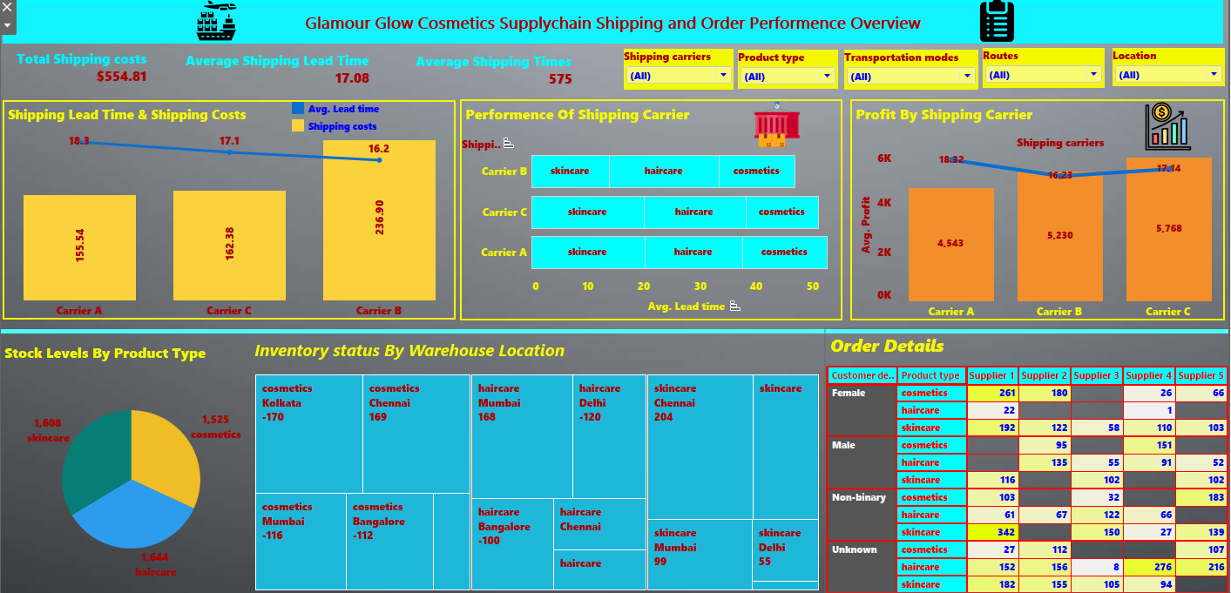

Glamour Glow Supply chain Manufacturing Performance

**Overall Manufacturing Performance:**

* **Total Production Volume:** 56,784 units, indicating a substantial manufacturing output.
* **Total Manufacturing Costs:** $4,727, which seems quite low relative to the production volume. This could imply efficient processes or simply represent a portion of total costs (e.g., direct labor, raw materials, but not overhead).
* **Average Defect Rate:** 2.28%, which is a manageable but improvable defect rate.
* **Total Defect Count:** 4,777 units, a significant number of defective products.

**Production Volume vs. Demand & Lead Times:**

* **Skincare Dominance:** Skincare products have the highest production volume (24,366 units) and the longest manufacturing lead time (2,099). This indicates high demand but also potential bottlenecks in production.
* **Haircare Production:** Haircare has the second highest volume (19,957 units) with a lead time of 1,480.
* **Cosmetics Production:** Cosmetics have the lowest volume (12,461 units) and the shortest lead time (1,343).
* **Lead Times:** The lead times (1,343 to 2,099) are presented as single numbers without units, but if these are days or hours, they are extremely long, indicating significant manufacturing delays. Assuming they are in a relative unit for comparison, skincare consistently takes longer.

**Manufacturing Costs vs. Inspection Status:**

* **Higher Costs for Higher Volumes:** Skincare, with the highest production volume, also has the highest manufacturing costs ($1,658.73), followed by haircare ($1,647.57), and cosmetics ($1,119.37).
* **Defect Distribution:**
  + **Skincare:** Has the highest number of "Fail" units (7,658) and "Pending" units (10,464) from inspection, indicating significant quality issues or backlogs.
  + **Haircare:** Also has a high number of "Fail" (7,494) and "Pending" (9,303) units.
  + **Cosmetics:** Has the lowest "Fail" (2,228) and "Pending" (5,557) units, aligning with its lower production volume.
* **Consistency of Pass Rates:** The number of "Pass" units are relatively consistent across categories (6,244 for skincare, 6,244 for haircare, 6,244 for cosmetics), which seems unlikely unless it's a fixed batch size passing. This might be a data representation issue or a strong signal of consistent "good" output batches regardless of volume.

**Order Lead Time vs. Manufacturing Lead Time:**

* **Significant Gaps:** For all product types, the "Order Lead Time" is consistently higher than the "Manufacturing Lead Time."
  + Cosmetics: Order Lead Time (346) vs Manufacturing Lead Time (300).
  + Haircare: Order Lead Time (580) vs Manufacturing Lead Time (528).
  + Skincare: Order Lead Time (551) vs Manufacturing Lead Time (400).
  + This indicates that delays occur not just in manufacturing, but also in other stages of the order fulfillment process (e.g., order processing, shipping, or warehousing). The units here are also unclear, but the trend of order lead time being longer than manufacturing lead time is significant.

**Transportation Modes & Costs:**

* **Road Transportation is Most Expensive:** For all product types (Cosmetics, Haircare, Skincare), "Road" transportation incurs the highest costs.
* **Air Transportation is Often Cheapest:** For Cosmetics ($1,970) and Haircare ($2,119), "Air" transportation is the cheapest. For Skincare, "Sea" is the cheapest ($2,366), and "Air" is the most expensive ($8,434). This discrepancy for skincare's "Air" cost is notable.
* **Rail:** Costs are in the mid-range.
* **Sea:** Cheapest for skincare, and generally competitive.

**Manufacturing Costs vs. Transportation Costs:**

* **Skincare's High Total Cost:** Skincare has significantly higher total manufacturing and transportation costs combined ($22,229) compared to haircare ($17,329) and cosmetics ($13,889). This is driven by its high production volume and potentially high individual unit transportation costs (especially for air).

**Revenue by Location & Product Type:**

* **Mumbai and Kolkata are High Revenue Generators:** Both locations show high revenue across all product types.
* **Chennai and Bangalore:** Also contribute significantly.
* **Delhi:** Appears to have lower revenue compared to the other locations.
* **Skincare is the Top Revenue Driver:** Across almost all locations, skincare generates the highest revenue.
* **Cosmetics Revenue:** Lower in comparison, but consistent across locations.
* **Haircare Revenue:** Moderate across locations.

**Business Recommendations**

1. **Address Skincare Manufacturing Bottlenecks & Quality:**
   * **Recommendation:** Skincare has the highest production volume but also the longest lead times and the most "Fail" and "Pending" units from inspection. This indicates significant inefficiencies and quality issues.
   * **Action:**
     + **Process Optimization:** Conduct a thorough review of the skincare manufacturing process to identify and eliminate bottlenecks. This might involve Lean or Six Sigma methodologies.
     + **Quality Control Enhancement:** Invest in improving quality control for skincare. Analyze the root causes of the high "Fail" rate. Are there issues with raw materials, equipment, or operator training?
     + **Capacity Expansion:** If demand continues to outpace current capacity, consider investing in additional skincare manufacturing equipment or shifting production to less utilized lines/facilities.
2. **Investigate & Improve Inspection Processes:**
   * **Recommendation:** The high number of "Pending" units for all product types suggests a backlog in the inspection process. The large number of "Fail" units points to systemic quality issues.
   * **Action:**
     + **Increase Inspection Capacity:** If staffing or equipment is a limitation, consider adding resources to reduce the "Pending" backlog.
     + **Streamline Inspection:** Review inspection procedures for efficiency without compromising thoroughness.
     + **Feedback Loop:** Ensure a strong feedback loop from inspection results back to the manufacturing floor to prevent recurrence of defects.
     + **Automate Inspection:** Explore automated inspection technologies where feasible to improve speed and accuracy.
3. **Optimize Shipping Costs & Modes:**
   * **Recommendation:** "Road" transportation is consistently the most expensive. There's a significant anomaly for "Air" transportation for skincare.
   * **Action:**
     + **Re-evaluate Road Transport:** For high-volume routes, analyze why road transport is so expensive. Can better rates be negotiated? Are there opportunities to shift to rail or sea for certain segments?
     + **Investigate Skincare Air Costs:** Understand why "Air" for skincare is disproportionately expensive. Is it due to product weight/volume, specific routes, or a particular carrier? This needs immediate attention.
     + **Strategic Mode Selection:** Implement a dynamic system for selecting transportation modes based on cost, urgency, and destination. Leverage "Sea" for skincare where lead times allow, and "Air" for cosmetics and haircare where it's cost-effective.
4. **Analyze and Reduce Total Order Lead Time:**
   * **Recommendation:** The fact that order lead times are longer than manufacturing lead times indicates post-production delays.
   * **Action:**
     + **Map the entire order fulfillment process:** From order placement to customer delivery.
     + **Identify Post-Manufacturing Bottlenecks:** Look for delays in warehousing, picking, packing, staging, and final mile delivery.
     + **Improve Coordination:** Enhance communication and coordination between manufacturing, warehousing, and shipping departments.
5. **Leverage High-Revenue Locations:**
   * **Recommendation:** Mumbai and Kolkata are strong revenue generators.
   * **Action:**
     + **Localized Marketing:** Intensify marketing and sales efforts in these high-performing regions.
     + **Inventory Optimization:** Ensure adequate stock levels and efficient distribution to these locations to meet demand.
     + **Feedback from Regional Sales:** Gather insights from sales teams in these areas to understand product preferences and market trends.
6. **Review Delhi's Performance:**
   * **Recommendation:** Delhi appears to be an outlier with lower revenue.
   * **Action:** Conduct a deeper dive into Delhi's market. Are there specific challenges (competition, distribution, local preferences) contributing to lower revenue? Explore targeted initiatives to boost sales in this region.
7. **Data Clarity on Units and Lead Times:**
   * **Recommendation:** The units for "Average Defect Rate," "Lead times" and "Order Lead Time vs. Manufacturing Lead Time" are ambiguous.
   * **Action:** Clarify the units for these metrics on the dashboard to enable more precise analysis and decision-making. (e.g., days, hours, percentage).

By implementing these recommendations, Glamour Glow Cosmetics can enhance its manufacturing efficiency, improve product quality, optimize logistics costs, and ultimately drive greater profitability and customer satisfaction.

